**NAME : PRADEEP SHARMA**

**COURSE : BCA**

**SEM : 6TH**

**ROLL NO. : 2092036**

**SUBJECT : SCRIPTING LANGUAGE**

**Date : 17-03-2023**

**PRACTICAL 3:** Implementation of popup of alert and confirm.

**Code:**

<!DOCTYPE html>

<html>

<head>

<title>Popup Box Example</title>

</head>

<body>

<h1>Popup Box Example</h1>

<button onclick="showAlert()">Show Alert</button>

<button onclick="showConfirm()">Show Confirm</button>

<script>

function showAlert() {

alert("This is an alert message!");

}

function showConfirm() {

var result = confirm("Are you sure you want to delete this item?");

if (result == true) {

alert("You clicked OK!");

} else {

alert("You clicked Cancel!");

}

}

</script>

</body>

</html>

**Output:**

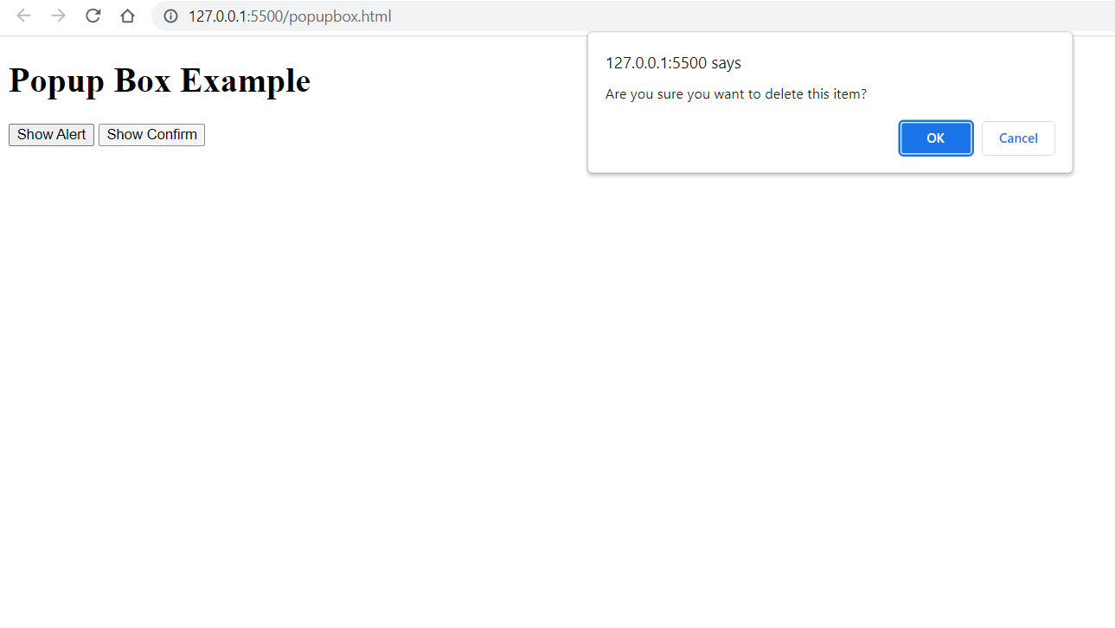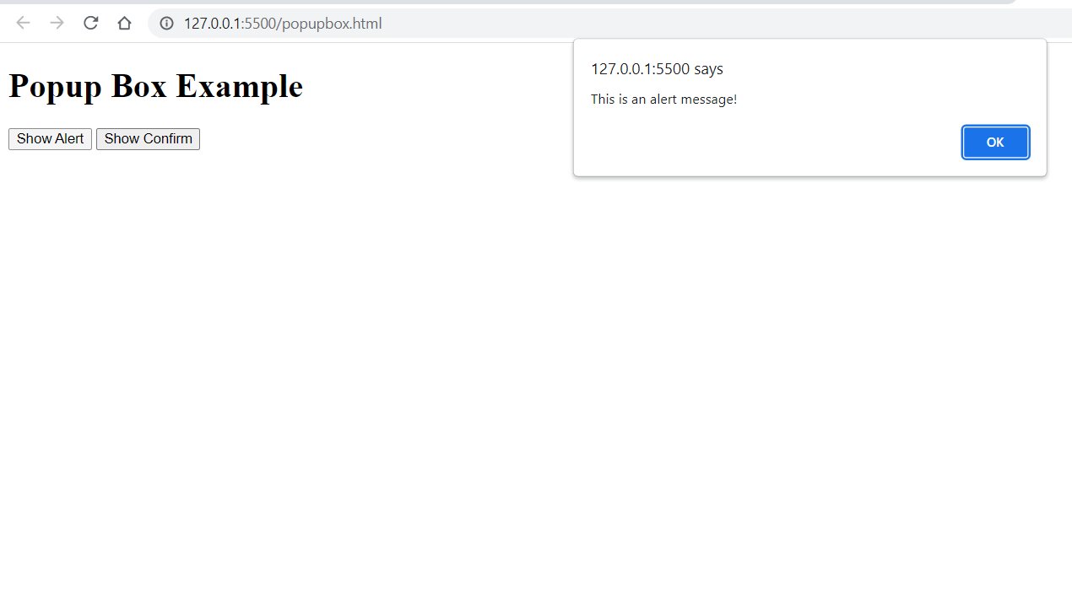

**NAME : PRADEEP SHARMA**

**COURSE : BCA**

**SEM : 6TH**

**ROLL NO. : 2092036**

**SUBJECT : SCRIPTING LANGUAGE**

**Date : 24-03-2023**

**PRACTICAL 4:** Implementation the CSS Box Model.

**Code:**

<!DOCTYPE html>

<html>

<head>

<title>CSS Box Model Example</title>

<style>

/* Define styles for the outer box */

.outer-box {

width: 200px;

height: 200px;

background-color: lightblue;

border: 10px solid black;

padding: 20px;

margin: 50px;

}

/* Define styles for the inner box */

.inner-box {

width: 100%;

height: 100%;

background-color: white;

border: 10px solid red;

padding: 20px;

box-sizing: border-box;

}

</style>

</head>

<body>

<div class="outer-box">

<div class="inner-box">

This is an example of the CSS box model.

</div>

</div>

</body>

</html>

**Output:**

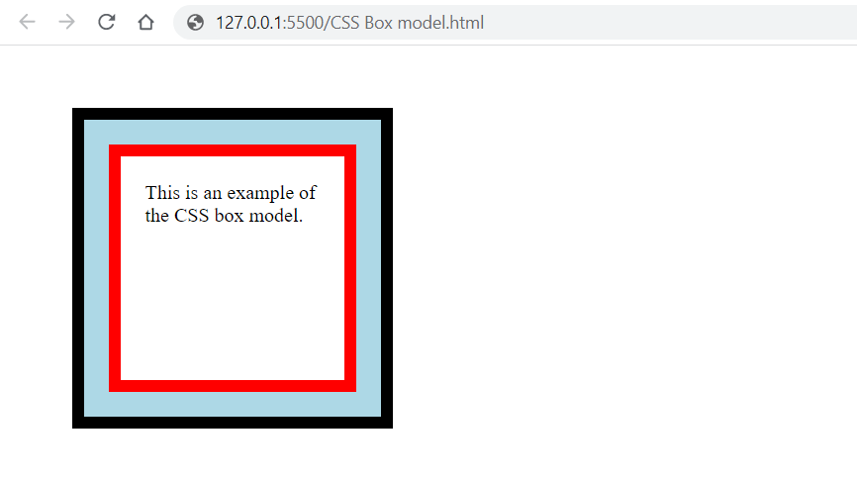

**NAME : PRADEEP SHARMA**

**COURSE : BCA**

**SEM : 6TH**

**ROLL NO. : 2092036**

**SUBJECT : SCRIPTING LANGUAGE**

**Date : 24-03-2023**

**PRACTICAL 5:** Design the webpage by applying the different style using inline, internal and external style sheet.

**Code:**

<!DOCTYPE html>

<html>

<head>

<title>Styles Example</title>

<!-- Internal Styles -->

<style>

h1 {

color: blue;

font-size: 36px;

text-align: center;

}

p {

font-size: 20px;

line-height: 1.5;

}

</style>

<!-- External Styles -->

<link rel="stylesheet" type="text/css" href="styles.css">

</head>

<body>

<!-- Inline Styles -->

<div style="background-color: yellow; padding: 20px;">

<h1 style="color: red;">Styles Example</h1>

<p style="text-align: justify;">This is an example of applying styles using inline, internal and external style sheets. The heading is styled with inline styles, the paragraph is styled with internal styles, and the background color and padding of this div are styled with inline styles.</p>

</div>

<!-- External Styles -->

<div class="external-styles">

<h2>External Styles</h2>

<p>This div is styled using an external style sheet.</p>

<button class="btn">Click me</button>

</div>

</body>

</html>

**CSS CODE-:**

/* External Styles */

.external-styles {

background-color: lightblue;

padding: 20px;

}

.external-styles h2 {

color: white;

font-size: 24px;

}

.external-styles p {

font-size: 16px;

line-height: 1.5;

}

.external-styles .btn {

background-color: green;

color: white;

border: none;

padding: 10px;

border-radius: 5px;

cursor: pointer;

}

.external-styles .btn:hover {

background-color: darkgreen;

}

**Output:**

